Title of the paper

Diego Oliva , Other names

Departamento de Ciencias Computacionales,

Tecnológico de Monterrey, Campus Guadalajara,

Av. Gral. Ramón Corona 2514, Zapopan, Jal, México

¹diego.oliva@itesm.mx

Abstract
Write the abstract here bla blab bla… Write the abstract here bla blab bla… Write the abstract here bla blab bla… Write the abstract here bla blab bla… Write the abstract here bla blab bla… Write the abstract here bla blab bla… Write the abstract here bla blab bla… Write the abstract here bla blab bla… Write the abstract here bla blab bla… Write the abstract here bla blab bla… Write the abstract here bla blab bla… Write the abstract here bla blab bla… Write the abstract here bla blab bla… Write the abstract here bla blab bla… Write the abstract here bla blab bla… Write the abstract here bla blab bla… Write the abstract here bla blab bla… Write the abstract here bla blab bla… Write the abstract here bla blab bla… Write the abstract here bla blab bla… Write the abstract here bla blab bla…
Keywords: Keyword1; Keyword2; Keyword3.
1. Introduction

Write here the introduction

2. Section 2
More text
2.1 Subsection
In this model they are not considered the magnetizing reactance and the rotor reactance, for that reason its accuracy is lower than other circuit models. On the other hand here are considered the following manufacturer data:
- List
- List
- Lis
Check equations are in tables, when you finish quit the borders of table.
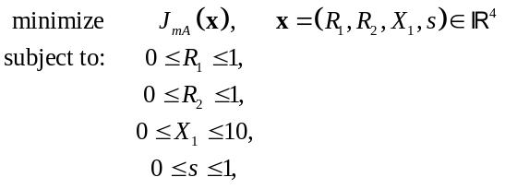 | (1)
Check figures Fig. 1.
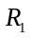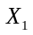
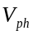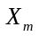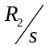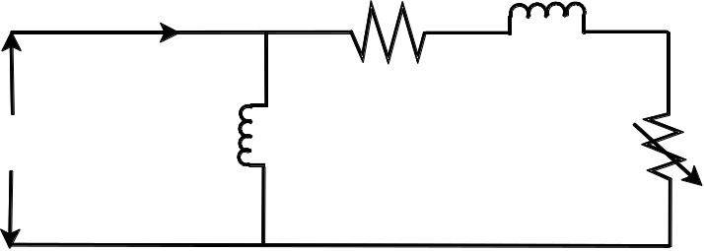
Figure 1. Here his the Figuere caption.
2.2 Other subsection
More text more and more…

3. Another section
More text…. Check the algorithm please
Algorithm 1 [EMO (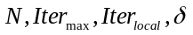)]
- Input parameters: Maximum number of iteration 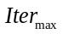, values for the local search parameter such 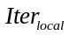 and , and the size 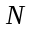of the population.
- Initialize: set the iteration counter 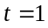, initialize the number of 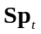 uniformly in P and identify the best point in .
- while 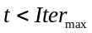 do
- 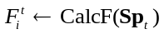
- 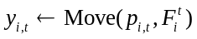
- 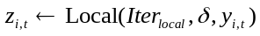
- 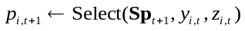
- end while

Please check how tables are defined
Parameter | Motor 1 | Motor 2
Capacity (HP) | 5 | 40
Voltage (V) | 400 | 400
Current (A) | 8 | 45
Frequency (Hz) | 50 | 50
No. Poles | 4 | 4
Full load slip | 0.07 | 0.09
Starting torque | 15 | 260
Max. torque | 42 | 370
Statin current | 22 | 180
Full load torque | 25 | 190
Table 1. Table caption.

For multiple figures use tables and when you finish quit the borders
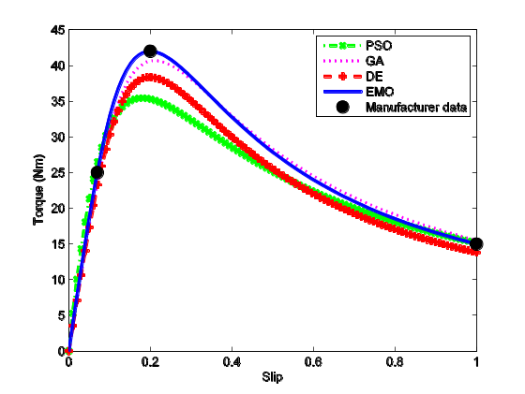  (a) | 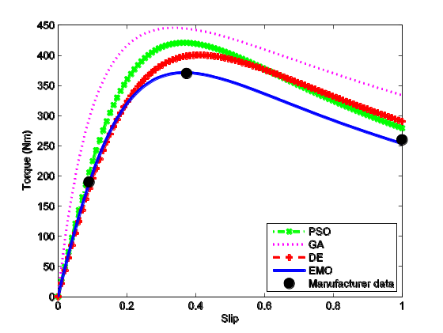  (b)
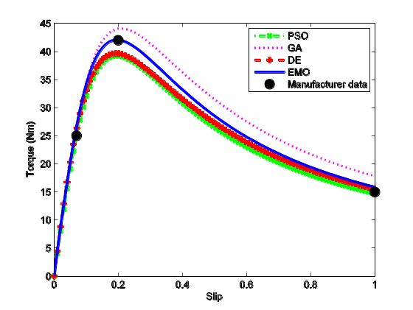  (c) | 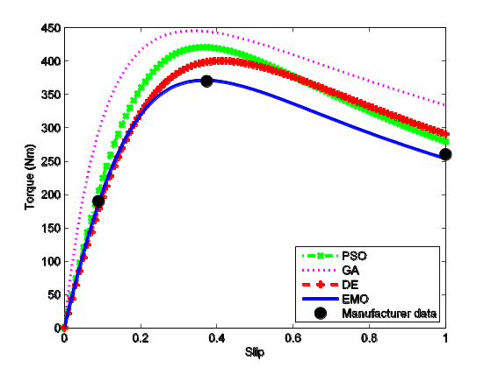  (d)
Figure 3. Caption of figure.

On the performance of the optimization algorithms used in the experiments is verified with the evolution of the two objective function for each motor model. The evolution of the objective function along 500 iteration is presented in Fig. 4. Since the approximate circuit model has less parameters to estimate all the algorithms converges in less than 100 iterations. However, since the exact circuit model the situation is different, the algorithms can fail in suboptimal values, for instance the GA in most of the cases converges this kind of solutions. In the same context PSO and DE requires a large amount of iterations to converge near to the best value, it means that EMO is able to accurately find the global optimal in a reduced number of iterations. The graphs of Fig. 4 show the efficiency of the compared optimization methods, there exist some similarities between them. However, EMO requires a less number of iterations to converge, this facts represents an advantage in the reduction of the computational effort.
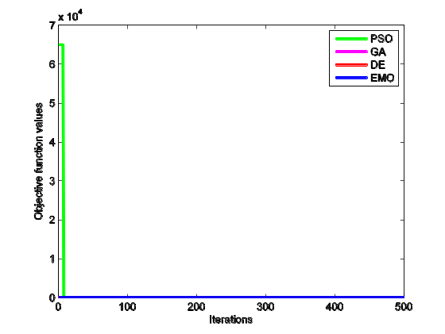  (a) |  | 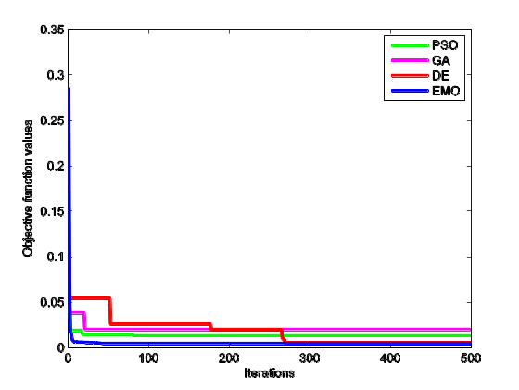  (b)
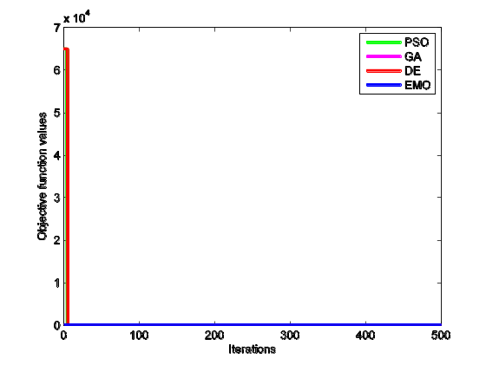  (c) |  | 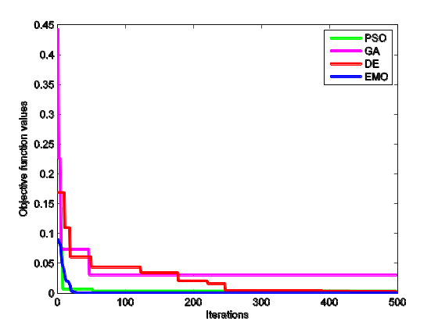  (d)
Figure 4. Evolution of the objective functio values: (a) Motor 1 - Approximate model , (b) Motor 2 - Approximate model, (c) Motor 1 - Exact model, (d) Motor 2 - Exact model.
References
[1] V.P. Sakthivel, R. Bhuvaneswari, S. Subramanian, Artificial immune system for parameter estimation of induction motor, Expert Syst. Appl. 37 (2010) 6109–6115. doi:10.1016/j.eswa.2010.02.034.
[2] H.R. Mohammadi, A. Akhavan, Parameter Estimation of Three-Phase Induction Motor Using Hybrid of Genetic Algorithm and Particle Swarm Optimization, J. Eng. 2014 (2014).

Corresponding author, Tel +52 33 1378 5900, ext. 27714, E-mail: diego.oliva@itesm.mx

